**Wire-Frame Design**

**CAMPUS PLACEMENT PREDICTION**

**Homepage**

On the homepage the user will be able to see the heading of the project name and after that there will be inputs which user needs to give.

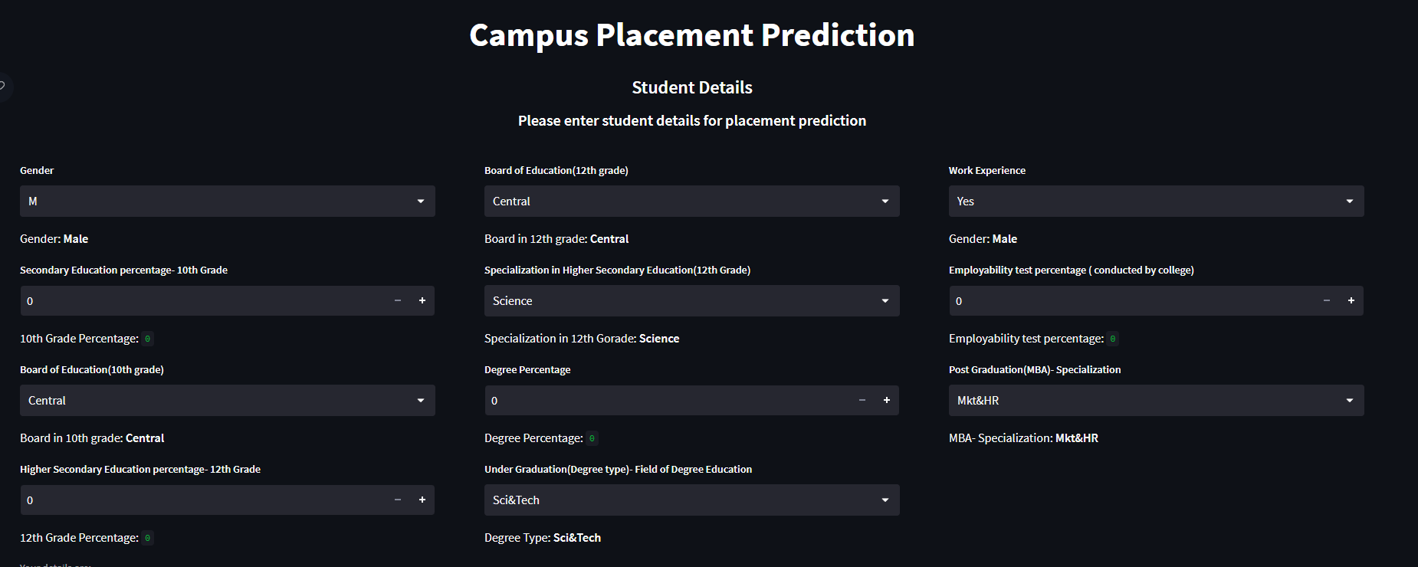

**Prediction Page**

After the user will give inputs there will be predict button, on clicking predict button the next page will open which will be the result page where the prediction will be shown for the given inputs. Below is the image how the result page will look like:

